Federal State Budgetary Educational Institution of Higher Education. "National Research University "MPEI"

Department of VMSS

Laboratory work No. 1

CONSTRUCTION OF A MEMORY DEVICE

Course: EVMiPU

Completed by:

Selyukov Konstantin

Team No. 6

Group A-09-19

Moscow 2022

Laboratory task 1.

Part 1

Build a memory device according to the option given in table 1.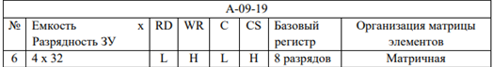

Table 1. Lab work option. Part 1

Figure 1. Storage device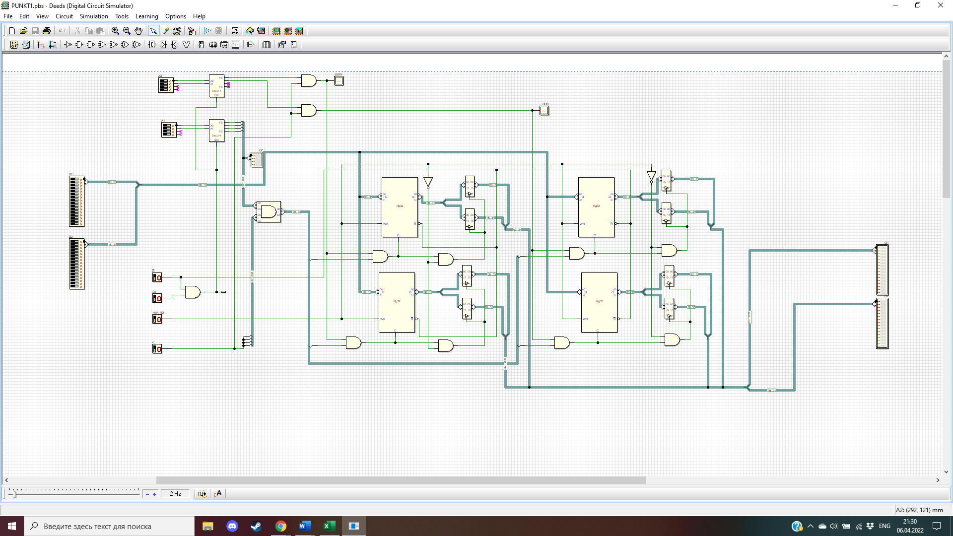

RG32

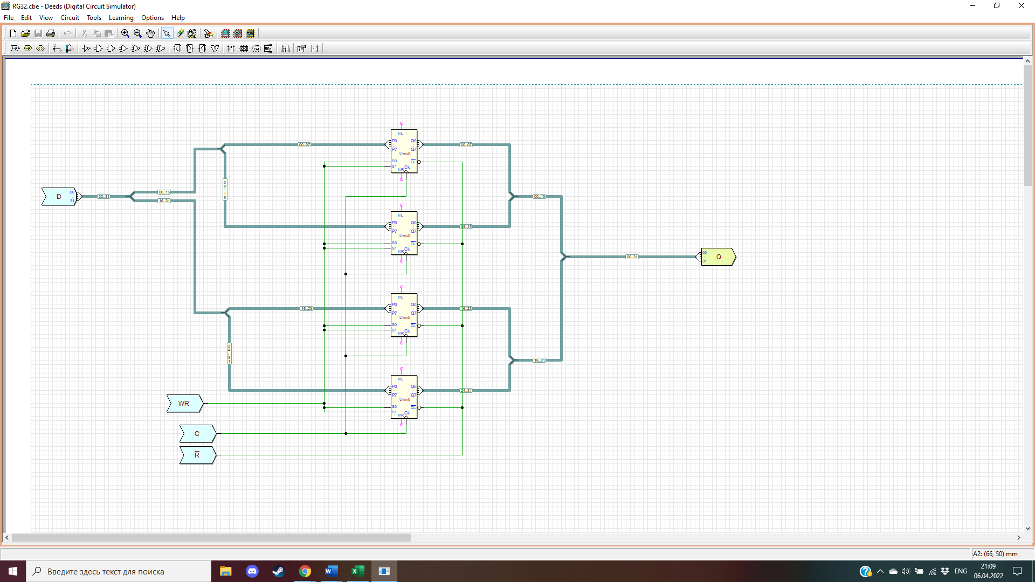

2. Construct timing diagrams of memory operation (reading and writing), which contain the following signals:

− data buses A, D, Q;

− control signals RD, WR, CS, C.

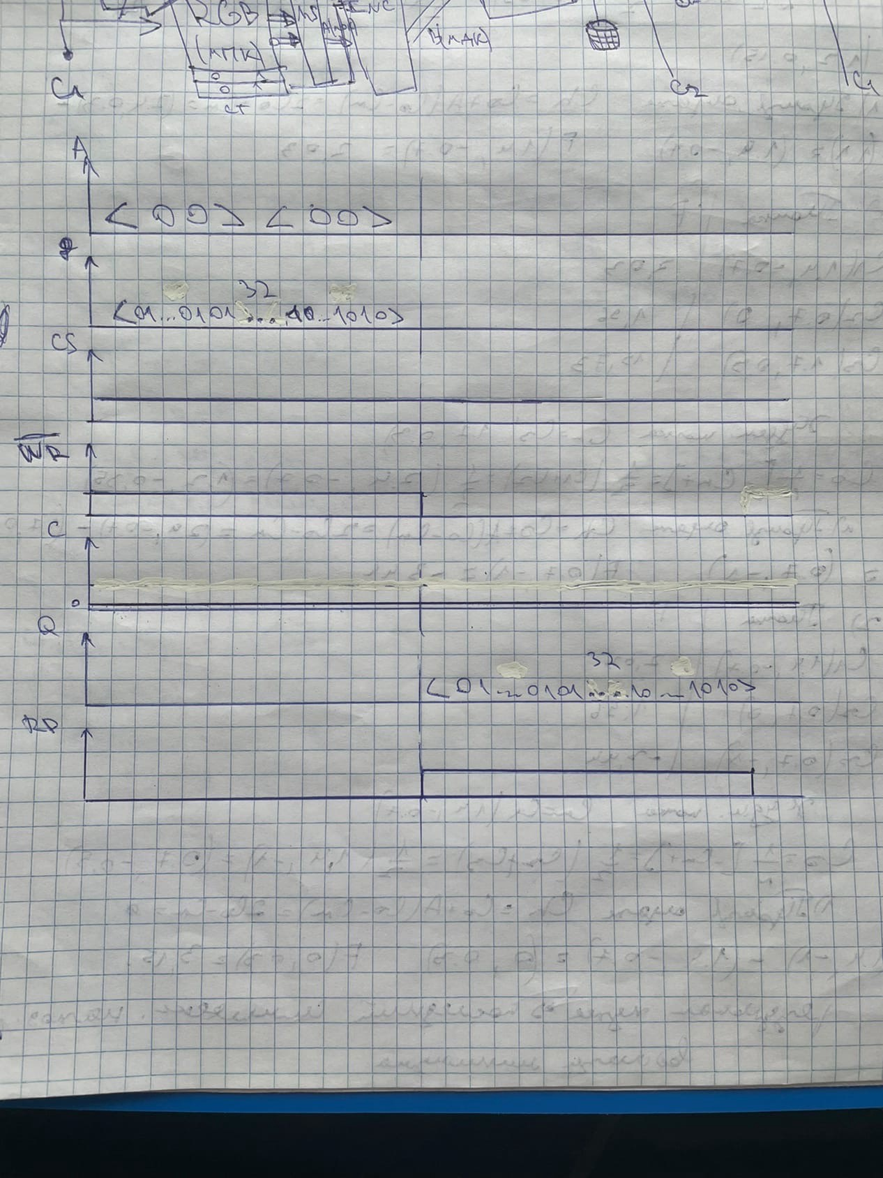

Figure 2.1. Timing diagrams

Task 2.

2. Construct a memory device with a control unit according to the option given in Table 2.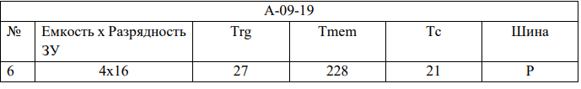

The following notations are used in the table:

− No. – variant number according to the list of teams;

− Trg – register response time (ns);

− Tmem – memory response time (ns);

− Tc – clock signal period (ns).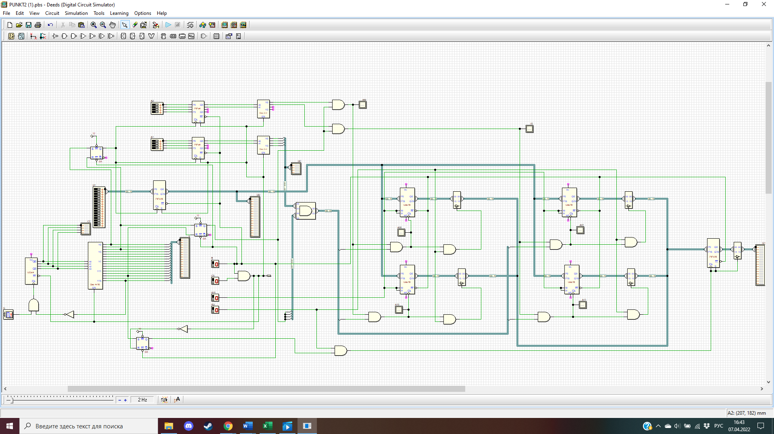

Figure 3.1. Memory circuit

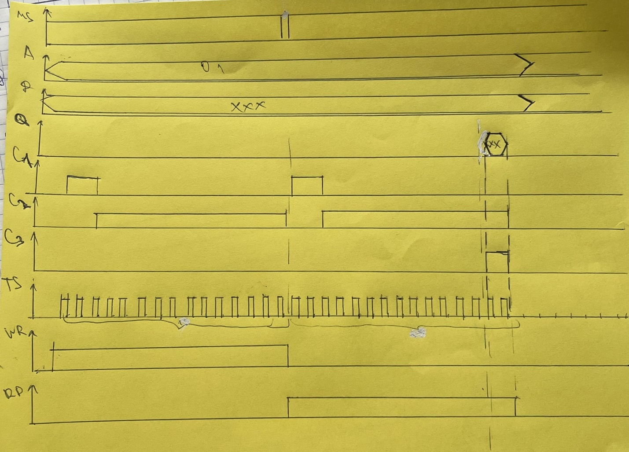Figure 3.2. Timing diagram

Part 3

Lab task

1. Build a circuit containing a memory device and a DMC8 microcontroller.

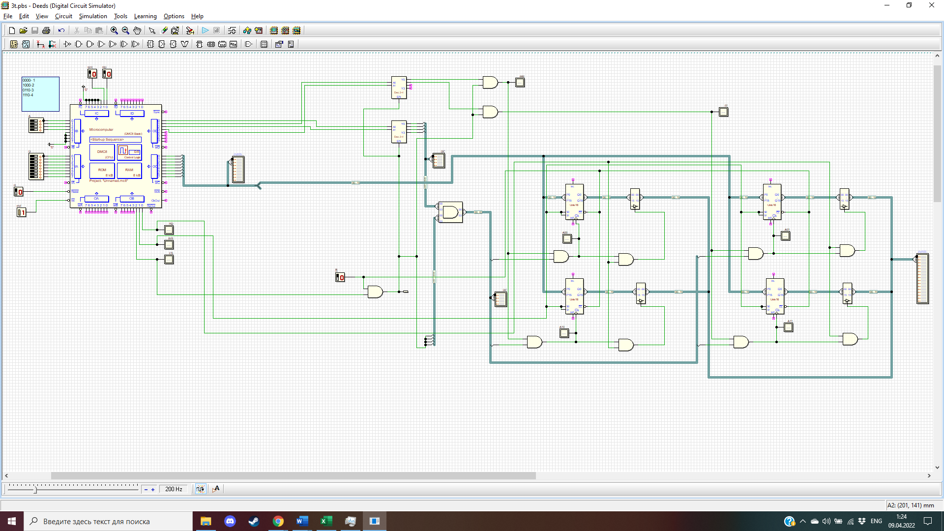

2. Write a program that allows you to receive an address and data from ports. When an interrupt arrives, perform a read or write operation to the connected memory.

portA EQU 00

portB EQU 01

portC EQU 02

portD EQU 03

JP START

ORG 38h

JP INT

ORG 100H

START:

EI

inf:

JP inf

INT:

IN A, (portB)

LD B, A

IN A, (portA)

LD D, A

LD A, B

OUT (portD), A

LD A, D

OUT (portC), A

IN A, (portC)

OR 00000100b

OUT (portB), A

NOP

NOP

EI

RET